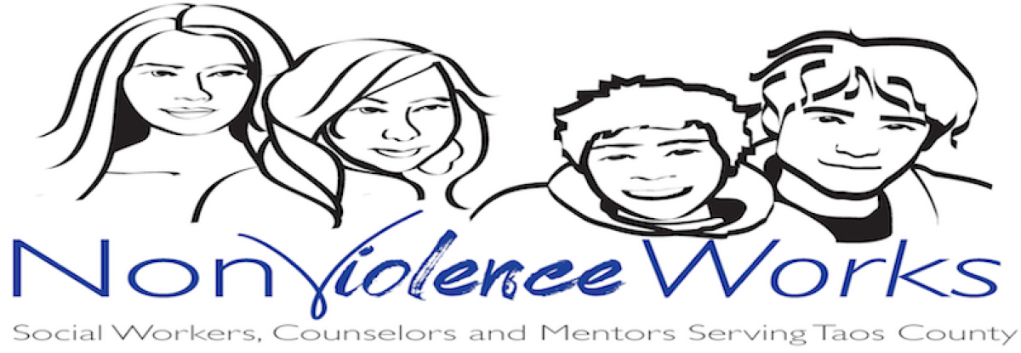
Youth Referral Form

PERSON BEING REFERRED
Name: ______________________________________________________________________
Date of Birth: _________________________________________________________________
Physical Address: ______________________________________________________________
Mailing Address: ______________________________________________________________
DESIRED PROGRAM
YOUTH PROGRAMS: □ Counseling □ Familia y Mundo □ Youth Camp
NAME OF INSURANCE COMPANY ___________________________________________________
Policy Number: _____________________________Phone #____________________________

PERSON MAKING REFERRAL
Name: __________________________________ Relationship_________________________

Please mail this form to:  NonViolence Works  P.O. Box 2238  Taos, NM 87571 | Or return it to us at:  NonViolence Works  1337 Gusdorf Road, Suite E  Taos, NM 87571

NonViolence Works, Inc. • Phone: 575-758-4297 • Fax: 575-751-7237 • www.nonviolenceworks.us

